hate as no-offensive

training 1 epoch...

/opt/conda/lib/python3.7/site-packages/ipykernel_launcher.py:41: UserWarning: To copy construct from a tensor, it is recommended to use sourceTensor.clone().detach() or sourceTensor.clone().detach().requires_grad_(True), rather than torch.tensor(sourceTensor).

84.89254236221313 seconds used......

1 training finished! average train loss: 0.674977386860471

total clf loss: 159.30984444916248 total adv loss: 108.30000433325768

evaluating...

Confusion matrix, without normalization

[[ 246 32 16]

[1080 2665 76]

[ 62 30 750]]

Normalized confusion matrix

[[0.83673469 0.10884354 0.05442177]

[0.28264852 0.6974614 0.01989008]

[0.0736342 0.03562945 0.89073634]]

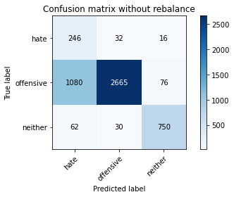

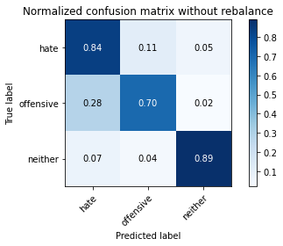

precision recall f1-score support

hate 0.18 0.84 0.29 294

offensive 0.98 0.70 0.81 3821

neither 0.89 0.89 0.89 842

accuracy 0.74 4957

macro avg 0.68 0.81 0.67 4957

weighted avg 0.92 0.74 0.80 4957

average eval_loss: 0.6275662891904393, accuracy: 0.7385515432721405

training 2 epoch...

/opt/conda/lib/python3.7/site-packages/ipykernel_launcher.py:41: UserWarning: To copy construct from a tensor, it is recommended to use sourceTensor.clone().detach() or sourceTensor.clone().detach().requires_grad_(True), rather than torch.tensor(sourceTensor).

84.85118126869202 seconds used......

2 training finished! average train loss: 0.3754522572680001

total clf loss: 89.07749355584383 total adv loss: 69.48757997900248

evaluating...

Confusion matrix, without normalization

[[ 213 59 22]

[ 621 3097 103]

[ 36 30 776]]

Normalized confusion matrix

[[0.7244898 0.20068027 0.07482993]

[0.1625229 0.81052081 0.02695629]

[0.04275534 0.03562945 0.9216152 ]]

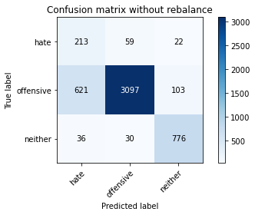

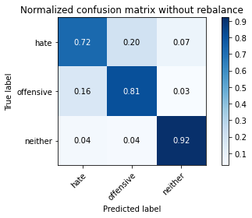

precision recall f1-score support

hate 0.24 0.72 0.37 294

offensive 0.97 0.81 0.88 3821

neither 0.86 0.92 0.89 842

accuracy 0.82 4957

macro avg 0.69 0.82 0.71 4957

weighted avg 0.91 0.82 0.85 4957

average eval_loss: 0.4092479999264381, accuracy: 0.8242888844058907

training 3 epoch...

/opt/conda/lib/python3.7/site-packages/ipykernel_launcher.py:41: UserWarning: To copy construct from a tensor, it is recommended to use sourceTensor.clone().detach() or sourceTensor.clone().detach().requires_grad_(True), rather than torch.tensor(sourceTensor).

84.76509308815002 seconds used......

3 training finished! average train loss: 0.26474014104327614

total clf loss: 63.02630982734263 total adv loss: 53.311154465191066

evaluating...

Confusion matrix, without normalization

[[ 243 30 21]

[1083 2627 111]

[ 55 15 772]]

Normalized confusion matrix

[[0.82653061 0.10204082 0.07142857]

[0.28343366 0.68751636 0.02904999]

[0.06532067 0.01781473 0.91686461]]

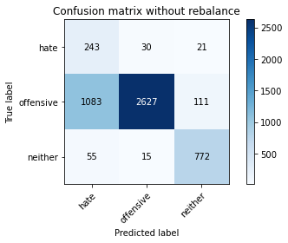

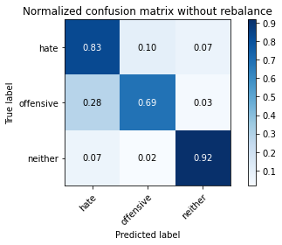

precision recall f1-score support

hate 0.18 0.83 0.29 294

offensive 0.98 0.69 0.81 3821

neither 0.85 0.92 0.88 842

accuracy 0.73 4957

macro avg 0.67 0.81 0.66 4957

weighted avg 0.91 0.73 0.79 4957

average eval_loss: 0.7211558334754493, accuracy: 0.734718579786161

training 4 epoch...

/opt/conda/lib/python3.7/site-packages/ipykernel_launcher.py:41: UserWarning: To copy construct from a tensor, it is recommended to use sourceTensor.clone().detach() or sourceTensor.clone().detach().requires_grad_(True), rather than torch.tensor(sourceTensor).

84.8557391166687 seconds used......

4 training finished! average train loss: 0.18919848379466617

total clf loss: 45.17260036431253 total adv loss: 40.706921653822064

evaluating...

Confusion matrix, without normalization

[[ 228 50 16]

[ 773 2943 105]

[ 50 24 768]]

Normalized confusion matrix

[[0.7755102 0.17006803 0.05442177]

[0.20230306 0.77021722 0.02747972]

[0.05938242 0.02850356 0.91211401]]

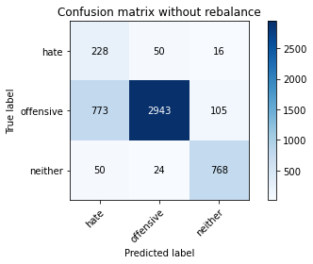

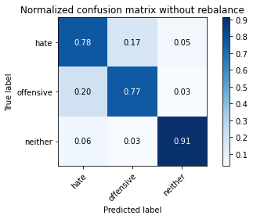

precision recall f1-score support

hate 0.22 0.78 0.34 294

offensive 0.98 0.77 0.86 3821

neither 0.86 0.91 0.89 842

accuracy 0.79 4957

macro avg 0.69 0.82 0.70 4957

weighted avg 0.91 0.79 0.83 4957

average eval_loss: 0.5476210785782094, accuracy: 0.7946338511196288

training 5 epoch...

/opt/conda/lib/python3.7/site-packages/ipykernel_launcher.py:41: UserWarning: To copy construct from a tensor, it is recommended to use sourceTensor.clone().detach() or sourceTensor.clone().detach().requires_grad_(True), rather than torch.tensor(sourceTensor).

84.88593554496765 seconds used......

5 training finished! average train loss: 0.11875036246911214

total clf loss: 28.458263008389622 total adv loss: 27.663607084192336

evaluating...

Confusion matrix, without normalization

[[ 249 30 15]

[1080 2632 109]

[ 83 13 746]]

Normalized confusion matrix

[[0.84693878 0.10204082 0.05102041]

[0.28264852 0.68882491 0.02852656]

[0.09857482 0.01543943 0.88598575]]

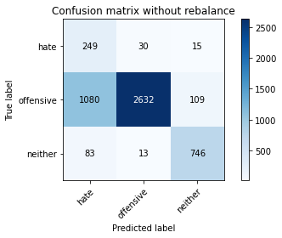

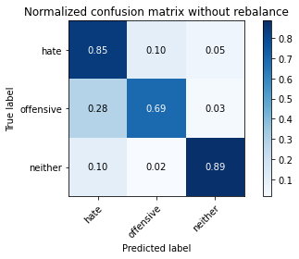

precision recall f1-score support

hate 0.18 0.85 0.29 294

offensive 0.98 0.69 0.81 3821

neither 0.86 0.89 0.87 842

accuracy 0.73 4957

macro avg 0.67 0.81 0.66 4957

weighted avg 0.91 0.73 0.79 4957

average eval_loss: 0.9660443750539305, accuracy: 0.7316925559814403

training 6 epoch...

/opt/conda/lib/python3.7/site-packages/ipykernel_launcher.py:41: UserWarning: To copy construct from a tensor, it is recommended to use sourceTensor.clone().detach() or sourceTensor.clone().detach().requires_grad_(True), rather than torch.tensor(sourceTensor).

84.72213172912598 seconds used......

6 training finished! average train loss: 0.08646996757076857

total clf loss: 20.69843365298584 total adv loss: 19.665622320957482

evaluating...

Confusion matrix, without normalization

[[ 250 33 11]

[1061 2700 60]

[ 106 28 708]]

Normalized confusion matrix

[[0.85034014 0.1122449 0.03741497]

[0.277676 0.7066213 0.0157027 ]

[0.12589074 0.03325416 0.84085511]]

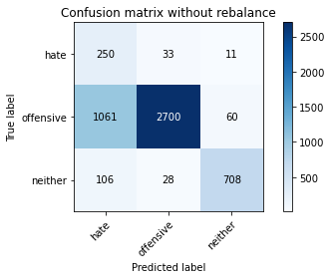

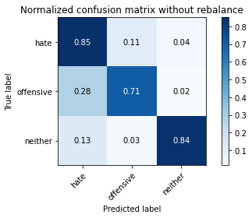

precision recall f1-score support

hate 0.18 0.85 0.29 294

offensive 0.98 0.71 0.82 3821

neither 0.91 0.84 0.87 842

accuracy 0.74 4957

macro avg 0.69 0.80 0.66 4957

weighted avg 0.92 0.74 0.80 4957

average eval_loss: 0.9119587595549234, accuracy: 0.7379463385111963

training 7 epoch...

/opt/conda/lib/python3.7/site-packages/ipykernel_launcher.py:41: UserWarning: To copy construct from a tensor, it is recommended to use sourceTensor.clone().detach() or sourceTensor.clone().detach().requires_grad_(True), rather than torch.tensor(sourceTensor).

84.62334418296814 seconds used......

7 training finished! average train loss: 0.0653884249040857

total clf loss: 15.692593818064779 total adv loss: 15.680658524972387

evaluating...

Confusion matrix, without normalization

[[ 196 79 19]

[ 521 3202 98]

[ 43 29 770]]

Normalized confusion matrix

[[0.66666667 0.26870748 0.06462585]

[0.13635174 0.83800052 0.02564774]

[0.05106888 0.03444181 0.91448931]]

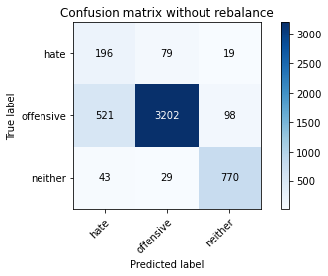

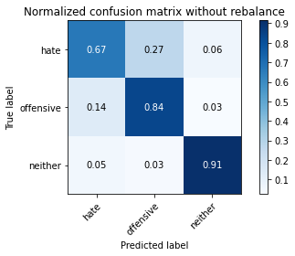

precision recall f1-score support

hate 0.26 0.67 0.37 294

offensive 0.97 0.84 0.90 3821

neither 0.87 0.91 0.89 842

accuracy 0.84 4957

macro avg 0.70 0.81 0.72 4957

weighted avg 0.91 0.84 0.87 4957

average eval_loss: 0.6480356705187907, accuracy: 0.8408311478716965

training 8 epoch...

/opt/conda/lib/python3.7/site-packages/ipykernel_launcher.py:41: UserWarning: To copy construct from a tensor, it is recommended to use sourceTensor.clone().detach() or sourceTensor.clone().detach().requires_grad_(True), rather than torch.tensor(sourceTensor).

84.8102707862854 seconds used......

8 training finished! average train loss: 0.04274331041399324

total clf loss: 10.195770479738712 total adv loss: 9.00591438083211

evaluating...

Confusion matrix, without normalization

[[ 189 81 24]

[ 420 3284 117]

[ 31 33 778]]

Normalized confusion matrix

[[0.64285714 0.2755102 0.08163265]

[0.10991887 0.85946087 0.03062026]

[0.0368171 0.0391924 0.9239905 ]]

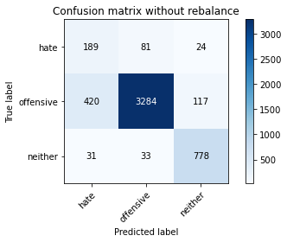

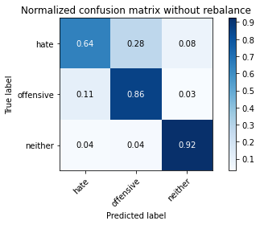

precision recall f1-score support

hate 0.30 0.64 0.40 294

offensive 0.97 0.86 0.91 3821

neither 0.85 0.92 0.88 842

accuracy 0.86 4957

macro avg 0.70 0.81 0.73 4957

weighted avg 0.91 0.86 0.88 4957

average eval_loss: 0.6407926189152205, accuracy: 0.8575751462578173

training 9 epoch...

/opt/conda/lib/python3.7/site-packages/ipykernel_launcher.py:41: UserWarning: To copy construct from a tensor, it is recommended to use sourceTensor.clone().detach() or sourceTensor.clone().detach().requires_grad_(True), rather than torch.tensor(sourceTensor).

84.59421110153198 seconds used......

9 training finished! average train loss: 0.02586479566985202

total clf loss: 6.162518045690376 total adv loss: 5.306892300373875

evaluating...

Confusion matrix, without normalization

[[ 206 68 20]

[ 602 3120 99]

[ 56 23 763]]

Normalized confusion matrix

[[0.70068027 0.23129252 0.06802721]

[0.15755038 0.81654017 0.02590945]

[0.06650831 0.02731591 0.90617577]]

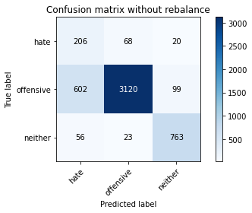

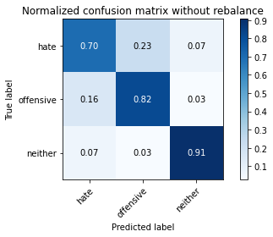

precision recall f1-score support

hate 0.24 0.70 0.36 294

offensive 0.97 0.82 0.89 3821

neither 0.87 0.91 0.89 842

accuracy 0.82 4957

macro avg 0.69 0.81 0.71 4957

weighted avg 0.91 0.82 0.86 4957

average eval_loss: 0.8548425340059909, accuracy: 0.8248940891668348

training 10 epoch...

/opt/conda/lib/python3.7/site-packages/ipykernel_launcher.py:41: UserWarning: To copy construct from a tensor, it is recommended to use sourceTensor.clone().detach() or sourceTensor.clone().detach().requires_grad_(True), rather than torch.tensor(sourceTensor).

84.94945001602173 seconds used......

10 training finished! average train loss: 0.023146964084222225

total clf loss: 5.562417832727078 total adv loss: 5.698200038197683

evaluating...

Confusion matrix, without normalization

[[ 226 52 16]

[ 713 3037 71]

[ 53 45 744]]

Normalized confusion matrix

[[0.76870748 0.17687075 0.05442177]

[0.18660037 0.79481811 0.01858152]

[0.06294537 0.05344418 0.88361045]]

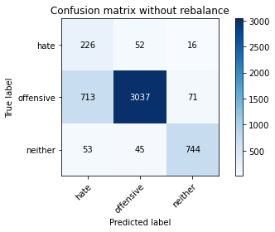

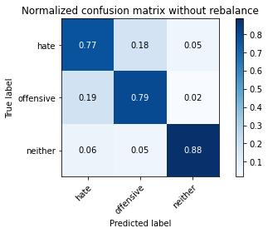

precision recall f1-score support

hate 0.23 0.77 0.35 294

offensive 0.97 0.79 0.87 3821

neither 0.90 0.88 0.89 842

accuracy 0.81 4957

macro avg 0.70 0.82 0.70 4957

weighted avg 0.91 0.81 0.85 4957

average eval_loss: 0.9047451848664505, accuracy: 0.8083518257010288

hate as offensive

training 1 epoch...

/opt/conda/lib/python3.7/site-packages/ipykernel_launcher.py:41: UserWarning: To copy construct from a tensor, it is recommended to use sourceTensor.clone().detach() or sourceTensor.clone().detach().requires_grad_(True), rather than torch.tensor(sourceTensor).

84.951167345047 seconds used......

1 training finished! average train loss: 0.6710841468813127

total clf loss: 156.83738268911839 total adv loss: 76.60393387451768

evaluating...

Confusion matrix, without normalization

[[ 217 64 13]

[ 504 3262 55]

[ 110 40 692]]

Normalized confusion matrix

[[0.73809524 0.21768707 0.04421769]

[0.13190264 0.85370322 0.01439414]

[0.13064133 0.04750594 0.82185273]]

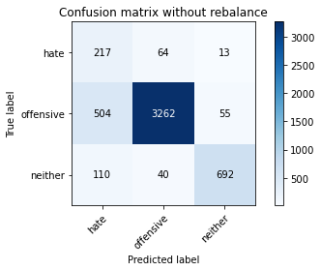

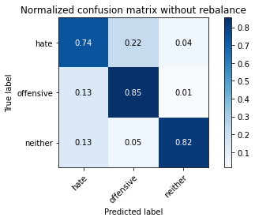

precision recall f1-score support

hate 0.26 0.74 0.39 294

offensive 0.97 0.85 0.91 3821

neither 0.91 0.82 0.86 842

accuracy 0.84 4957

macro avg 0.71 0.80 0.72 4957

weighted avg 0.92 0.84 0.87 4957

average eval_loss: 0.4095747876698517, accuracy: 0.8414363526326407

training 2 epoch...

/opt/conda/lib/python3.7/site-packages/ipykernel_launcher.py:41: UserWarning: To copy construct from a tensor, it is recommended to use sourceTensor.clone().detach() or sourceTensor.clone().detach().requires_grad_(True), rather than torch.tensor(sourceTensor).

84.79116535186768 seconds used......

2 training finished! average train loss: 0.3945090458319898

total clf loss: 91.85374666005373 total adv loss: 38.1136810593307

evaluating...

Confusion matrix, without normalization

[[ 222 57 15]

[ 638 3081 102]

[ 67 14 761]]

Normalized confusion matrix

[[0.75510204 0.19387755 0.05102041]

[0.166972 0.80633342 0.02669458]

[0.07957245 0.01662708 0.90380048]]

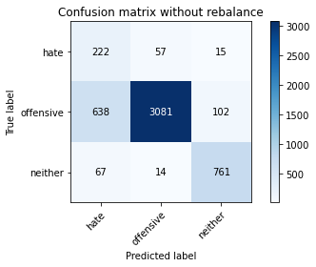

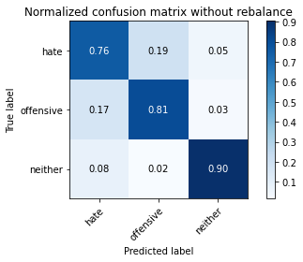

precision recall f1-score support

hate 0.24 0.76 0.36 294

offensive 0.98 0.81 0.88 3821

neither 0.87 0.90 0.88 842

accuracy 0.82 4957

macro avg 0.69 0.82 0.71 4957

weighted avg 0.91 0.82 0.85 4957

average eval_loss: 0.43614698382617845, accuracy: 0.8198507161589671

training 3 epoch...

/opt/conda/lib/python3.7/site-packages/ipykernel_launcher.py:41: UserWarning: To copy construct from a tensor, it is recommended to use sourceTensor.clone().detach() or sourceTensor.clone().detach().requires_grad_(True), rather than torch.tensor(sourceTensor).

84.89065957069397 seconds used......

3 training finished! average train loss: 0.26666387443414385

total clf loss: 61.75956735294312 total adv loss: 19.204083259915933

evaluating...

Confusion matrix, without normalization

[[ 216 49 29]

[ 778 2792 251]

[ 42 13 787]]

Normalized confusion matrix

[[0.73469388 0.16666667 0.09863946]

[0.20361162 0.73069877 0.06568961]

[0.04988124 0.01543943 0.93467933]]

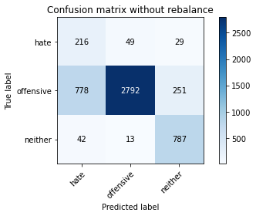

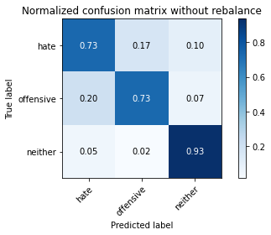

precision recall f1-score support

hate 0.21 0.73 0.32 294

offensive 0.98 0.73 0.84 3821

neither 0.74 0.93 0.82 842

accuracy 0.77 4957

macro avg 0.64 0.80 0.66 4957

weighted avg 0.89 0.77 0.80 4957

average eval_loss: 0.5966818460074796, accuracy: 0.765584022594311

training 4 epoch...

/opt/conda/lib/python3.7/site-packages/ipykernel_launcher.py:41: UserWarning: To copy construct from a tensor, it is recommended to use sourceTensor.clone().detach() or sourceTensor.clone().detach().requires_grad_(True), rather than torch.tensor(sourceTensor).

84.75878548622131 seconds used......

4 training finished! average train loss: 0.18806629960441537

total clf loss: 43.67083701491356 total adv loss: 15.834412801777944

evaluating...

Confusion matrix, without normalization

[[ 231 40 23]

[ 910 2757 154]

[ 46 13 783]]

Normalized confusion matrix

[[0.78571429 0.13605442 0.07823129]

[0.23815755 0.72153886 0.04030359]

[0.05463183 0.01543943 0.92992874]]

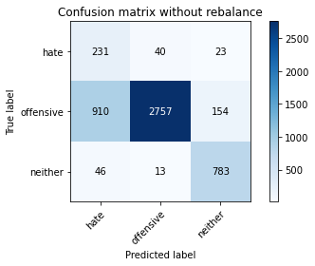

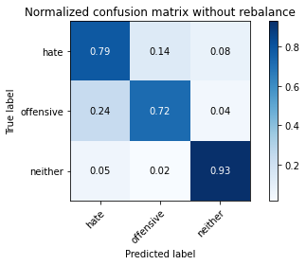

precision recall f1-score support

hate 0.19 0.79 0.31 294

offensive 0.98 0.72 0.83 3821

neither 0.82 0.93 0.87 842

accuracy 0.76 4957

macro avg 0.66 0.81 0.67 4957

weighted avg 0.91 0.76 0.81 4957

average eval_loss: 0.6942081894483586, accuracy: 0.7607423845067581

training 5 epoch...

/opt/conda/lib/python3.7/site-packages/ipykernel_launcher.py:41: UserWarning: To copy construct from a tensor, it is recommended to use sourceTensor.clone().detach() or sourceTensor.clone().detach().requires_grad_(True), rather than torch.tensor(sourceTensor).

84.77136445045471 seconds used......

5 training finished! average train loss: 0.11587287132064567

total clf loss: 26.900420838501304 total adv loss: 9.62812302299426

evaluating...

Confusion matrix, without normalization

[[ 247 37 10]

[1101 2647 73]

[ 122 21 699]]

Normalized confusion matrix

[[0.84013605 0.12585034 0.03401361]

[0.28814446 0.69275059 0.01910495]

[0.14489311 0.02494062 0.83016627]]

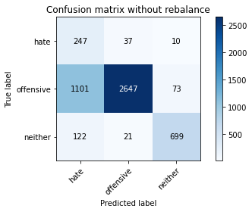

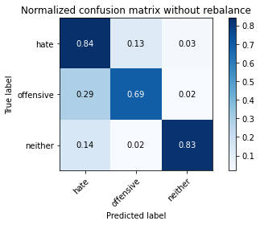

precision recall f1-score support

hate 0.17 0.84 0.28 294

offensive 0.98 0.69 0.81 3821

neither 0.89 0.83 0.86 842

accuracy 0.72 4957

macro avg 0.68 0.79 0.65 4957

weighted avg 0.92 0.72 0.79 4957

average eval_loss: 0.9253880992120982, accuracy: 0.7248335686907403

training 6 epoch...

/opt/conda/lib/python3.7/site-packages/ipykernel_launcher.py:41: UserWarning: To copy construct from a tensor, it is recommended to use sourceTensor.clone().detach() or sourceTensor.clone().detach().requires_grad_(True), rather than torch.tensor(sourceTensor).

84.83610010147095 seconds used......

6 training finished! average train loss: 0.08819548924772166

total clf loss: 20.45849402435124 total adv loss: 6.998448298429139

evaluating...

Confusion matrix, without normalization

[[ 238 44 12]

[ 937 2782 102]

[ 75 22 745]]

Normalized confusion matrix

[[0.80952381 0.14965986 0.04081633]

[0.24522376 0.72808165 0.02669458]

[0.08907363 0.02612827 0.8847981 ]]

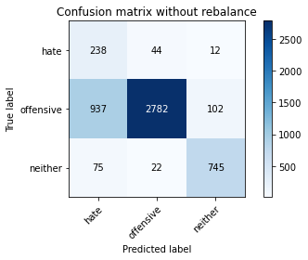

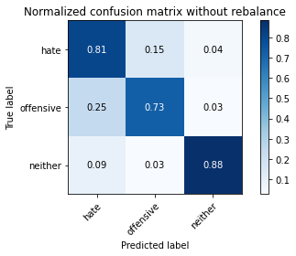

precision recall f1-score support

hate 0.19 0.81 0.31 294

offensive 0.98 0.73 0.83 3821

neither 0.87 0.88 0.88 842

accuracy 0.76 4957

macro avg 0.68 0.81 0.67 4957

weighted avg 0.91 0.76 0.81 4957

average eval_loss: 0.9640145060849683, accuracy: 0.7595319749848699

training 7 epoch...

/opt/conda/lib/python3.7/site-packages/ipykernel_launcher.py:41: UserWarning: To copy construct from a tensor, it is recommended to use sourceTensor.clone().detach() or sourceTensor.clone().detach().requires_grad_(True), rather than torch.tensor(sourceTensor).

84.90407729148865 seconds used......

7 training finished! average train loss: 0.0585492958075759

total clf loss: 13.605897563043982 total adv loss: 5.133161944220774

evaluating...

Confusion matrix, without normalization

[[ 222 56 16]

[ 722 3011 88]

[ 47 50 745]]

Normalized confusion matrix

[[0.75510204 0.19047619 0.05442177]

[0.18895577 0.78801361 0.02303062]

[0.05581948 0.05938242 0.8847981 ]]

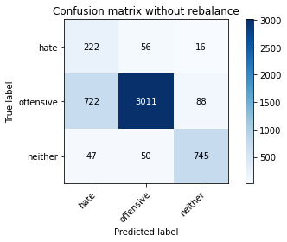

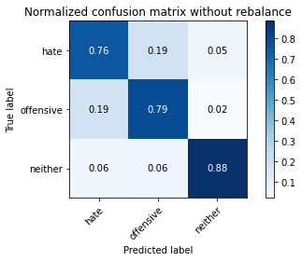

precision recall f1-score support

hate 0.22 0.76 0.35 294

offensive 0.97 0.79 0.87 3821

neither 0.88 0.88 0.88 842

accuracy 0.80 4957

macro avg 0.69 0.81 0.70 4957

weighted avg 0.91 0.80 0.84 4957

average eval_loss: 0.7921049074193159, accuracy: 0.8025015130119023

training 8 epoch...

/opt/conda/lib/python3.7/site-packages/ipykernel_launcher.py:41: UserWarning: To copy construct from a tensor, it is recommended to use sourceTensor.clone().detach() or sourceTensor.clone().detach().requires_grad_(True), rather than torch.tensor(sourceTensor).

84.77221608161926 seconds used......

8 training finished! average train loss: 0.02831457744622113

total clf loss: 6.568692209548317 total adv loss: 2.259370826308441

evaluating...

Confusion matrix, without normalization

[[ 211 62 21]

[ 620 3093 108]

[ 43 25 774]]

Normalized confusion matrix

[[0.71768707 0.21088435 0.07142857]

[0.16226119 0.80947396 0.02826485]

[0.05106888 0.02969121 0.9192399 ]]

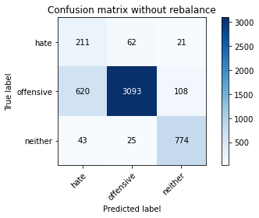

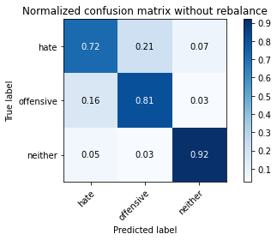

precision recall f1-score support

hate 0.24 0.72 0.36 294

offensive 0.97 0.81 0.88 3821

neither 0.86 0.92 0.89 842

accuracy 0.82 4957

macro avg 0.69 0.82 0.71 4957

weighted avg 0.91 0.82 0.85 4957

average eval_loss: 0.8515173428610328, accuracy: 0.822675005043373

training 9 epoch...

/opt/conda/lib/python3.7/site-packages/ipykernel_launcher.py:41: UserWarning: To copy construct from a tensor, it is recommended to use sourceTensor.clone().detach() or sourceTensor.clone().detach().requires_grad_(True), rather than torch.tensor(sourceTensor).

84.82868885993958 seconds used......

9 training finished! average train loss: 0.036971487813596535

total clf loss: 8.65730043349322 total adv loss: 4.556024044017249

evaluating...

Confusion matrix, without normalization

[[ 224 47 23]

[ 791 2911 119]

[ 56 26 760]]

Normalized confusion matrix

[[0.76190476 0.15986395 0.07823129]

[0.20701387 0.76184245 0.03114368]

[0.06650831 0.03087886 0.90261283]]

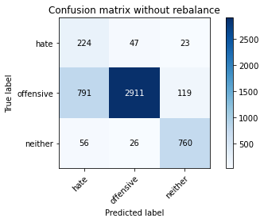

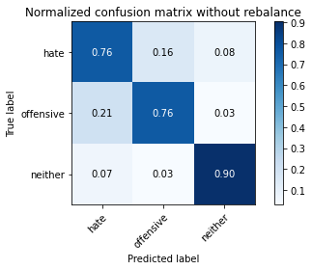

precision recall f1-score support

hate 0.21 0.76 0.33 294

offensive 0.98 0.76 0.86 3821

neither 0.84 0.90 0.87 842

accuracy 0.79 4957

macro avg 0.68 0.81 0.69 4957

weighted avg 0.91 0.79 0.83 4957

average eval_loss: 1.0354091579972393, accuracy: 0.7857575146257817

training 10 epoch...

/opt/conda/lib/python3.7/site-packages/ipykernel_launcher.py:41: UserWarning: To copy construct from a tensor, it is recommended to use sourceTensor.clone().detach() or sourceTensor.clone().detach().requires_grad_(True), rather than torch.tensor(sourceTensor).

84.87744975090027 seconds used......

10 training finished! average train loss: 0.0312821267176779

total clf loss: 7.288289094576612 total adv loss: 3.1192846470949007

evaluating...

Confusion matrix, without normalization

[[ 223 55 16]

[ 793 2908 120]

[ 53 20 769]]

Normalized confusion matrix

[[0.7585034 0.18707483 0.05442177]

[0.20753729 0.76105731 0.03140539]

[0.06294537 0.02375297 0.91330166]]

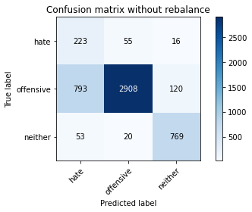

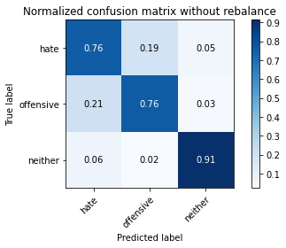

precision recall f1-score support

hate 0.21 0.76 0.33 294

offensive 0.97 0.76 0.85 3821

neither 0.85 0.91 0.88 842

accuracy 0.79 4957

macro avg 0.68 0.81 0.69 4957

weighted avg 0.91 0.79 0.83 4957

average eval_loss: 0.9996101926167051, accuracy: 0.7867661892273553